**[Op-Ed]**

**Cutting Edge: How Autonomous Robots Are Shaping the Future of Surgery**

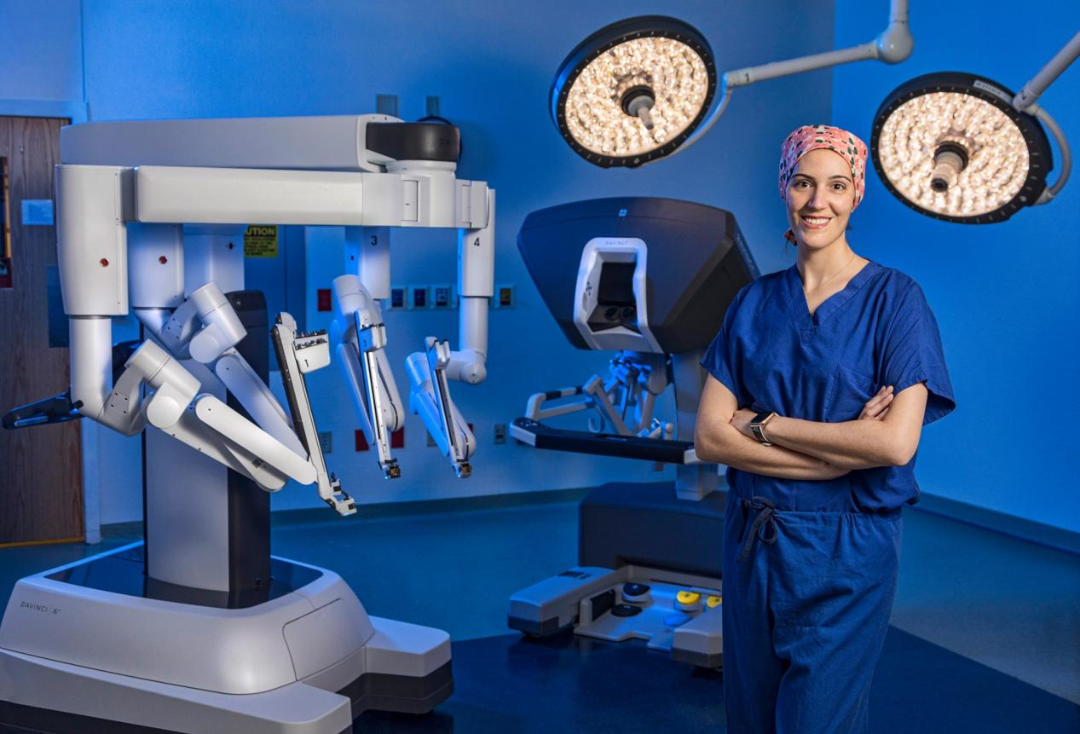

Figure 1. The Future Operating Room

When you lean on an operating table, anesthesiologist counts down from 10. And when it gets to 7, you see two figures moving over you. These are a robot and the operating surgeon. Surgical robots today are primarily used to assist surgeons in minimally invasive procedures, offering increased precision, dexterity, and control. With rapid advancements in artificial intelligence and robotics, fully autonomous surgical robots are likely to replace human surgeons in specific procedures within the next decade, offering greater precision, consistency, and efficiency in routine surgeries. As AI algorithms advance and hardware becomes more sophisticated, the operating room is undergoing a transformation, with robots increasingly taking on complex surgical tasks independently. This evolution will make us human feel twice as safe when lying on the operating table.

Table 1 Different types of surgical robots

|  |  |  |  |
| --- | --- | --- | --- |
| **Surgical Robot Systems** | **Type of Surgery** | **Success Rate (%)** | **Task It Excels At** |
| Da Vinci Surgical System | Prostatectomy | 90-98% | minimally invasive prostate surgeries;  lower rates of complications;  faster recovery times |
| Mako Robotic-Arm Assisted | Knee and Hip Replacement | 97-99% | orthopedic surgeries;  better outcomes in joint replacement |
| CorPath GRX | Percutaneous Coronary Angioplasty | 96-98% | clear blocked arteries in heart surgeries;  precise catheter placement;  improved procedure outcomes |
| ROSA Robotic System | Neurological Surgery | 93-95% | brain and spinal surgeries;  highly accurate targeting in complex neurological procedures |
| Versius | General and Colorectal Surgery | 92-96% | Compact design with modular arms;  minimally invasive surgeries |

Fully autonomous surgical robots promise to eliminate the variability inherent in human performance. Even the most skilled surgeons can experience fatigue, stress, or hand tremors, which can lead to errors during delicate operations. Autonomous systems, on the other hand, can perform with consistent precision for extended periods, regardless of external factors. They can also be programmed to make micromovements beyond the capabilities of the human hand, resulting in higher accuracy in procedures that demand meticulous detail. This would be especially beneficial in microsurgeries or procedures that require navigating narrow spaces, reducing complications and improving patient outcomes. In addition, autonomous robots are more likely to perform surgeries with minimally invasive techniques, reducing trauma to the body. These procedures lead to smaller incisions, less blood loss, and fewer postoperative complications such as infections. Over time, as fully autonomous systems perfect these techniques, the overall burden on healthcare institutions could decrease, freeing up resources for other medical needs and allowing hospitals to treat more patients efficiently.

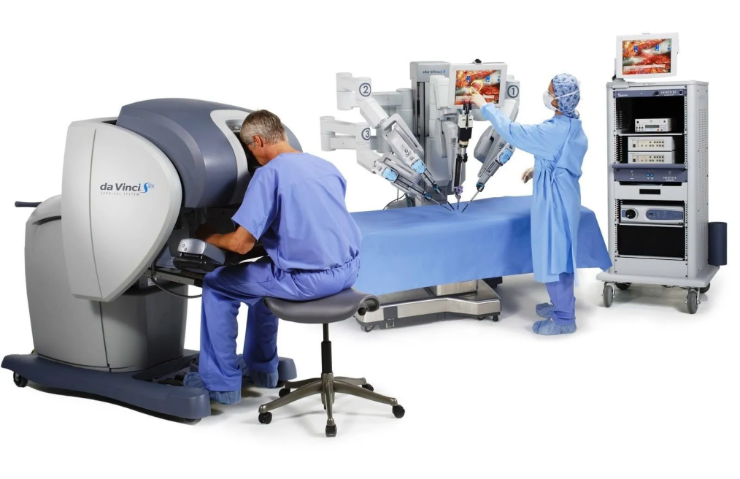

Figure 2 Da Vinci robotic surgical system

Today’s surgical robots, like the Da Vinci system, are primarily used to assist human surgeons, excelling in tasks that demand precision such as stabilizing instruments and minimizing hand tremors. These machines are equipped with multi-arm configurations and intuitive controls, making them indispensable for minimally invasive surgeries. However, while they reduce human error, they still require human surgeons to guide and control them. We are at the stage where robots augment, but do not replace, the role of the surgeon. The potential for surgical robots to achieve full autonomy is no longer science fiction—it’s a reality on the horizon.

One of the major bottlenecks preventing fully autonomous surgical robots from becoming mainstream is the complexity of surgical decision-making. Surgeons must make real-time judgment calls, adapting to unexpected complications or variations in patient anatomy. While robots can currently follow pre-programmed movements and execute tasks with precision, they still struggle with these unpredictable variables. Similarly, autonomous vehicles faced similar hurdles in their development—navigating unpredictable environments, reacting to sudden changes, and ensuring passenger safety. Initially, self-driving technology was limited to ideal conditions with well-defined roads, but with advances in machine learning, sensor technologies, and real-time data processing[1], autonomous vehicles are now capable of handling complex scenarios such as sudden pedestrian crossings or unpredictable weather. In the same way, we can expect surgical robots to improve their decision-making capabilities by integrating AI that learns from vast amounts of surgical data, adapting to anomalies in real-time. Just as the self-driving car’s sensors and algorithms allow it to navigate dynamic environments, surgical robots will be able to adjust mid-procedure, responding to unexpected complications with the precision and speed that surpass human capabilities. With continuous improvements in AI, sensor accuracy, and real-time feedback, it is only a matter of time before the bottlenecks of autonomous surgery are resolved, much like the strides we’ve seen in autonomous vehicles.

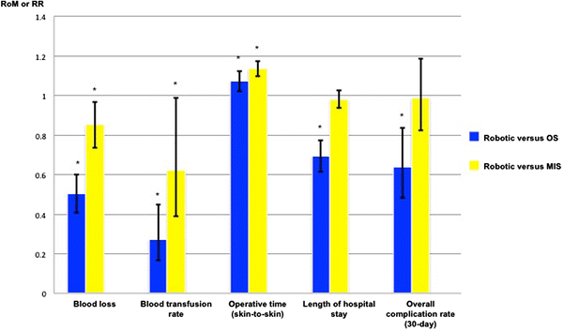

Figure 3 Pooled proportional change in perioperative outcomes for robotic versus open surgery and robotic versus minimally invasive surgery

Leading companies like Intuitive Surgical, Stryker, and Zimmer Biomet are at the forefront of this innovation, working to overcome the technical and ethical barriers that stand in the way of full automation. These companies are not just focused on creating robots that replicate human abilities but are developing platforms that could surpass human performance in routine and highly specific surgeries. For example, researchers at Johns Hopkins University have developed the Smart Tissue Autonomous Robot (STAR)[2], a system capable of performing soft tissue surgeries with remarkable precision, such as suturing, often outperforming human surgeons in terms of consistency and accuracy. Meanwhile, at MIT, researchers are developing robotic systems that can use real-time data from imaging technologies like MRI and CT scans to adjust surgical approaches dynamically, enabling more personalized and adaptive surgeries.

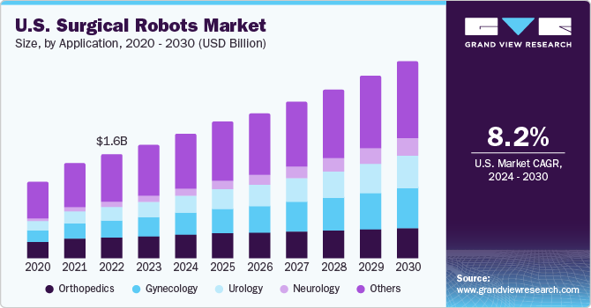

Figure 4 U.S. Surgical Robots Market

In addition to hardware advancements, breakthroughs in AI and machine learning are critical in pushing the boundaries of what surgical robots can achieve. For instance, research into reinforcement learning allows robots to refine their techniques through trial and error, mimicking the way human surgeons perfect their skills over time. Furthermore, AI-driven predictive analytics are being explored to anticipate complications during surgery before they arise, enhancing decision-making capabilities. Enhanced imaging technologies, such as hyperspectral imaging and intraoperative fluorescence-guided surgery, are also being integrated into robotic platforms to provide real-time, high-resolution data about tissues and blood flow, allowing robots to make more informed surgical decisions. With these innovations and real-time decision-making capabilities, the vision of fully autonomous surgical robots handling complex operations may become a reality in the next decade.

1. Purwanto, E. (2024). A Bibliometric Analysis of Trends and Collaborations in Autonomous Driving Research (2002-2024). Mechatron. Intell Transp. Syst., 3(2), 85-112. <https://doi.org/10.56578/mits030202>
2. Johns Hopkins University. (2022, January 26). Robot performs keyhole surgery on pig’s soft tissue. The Hub. <https://hub.jhu.edu/2022/01/26/star-robot-performs-intestinal-surgery/>

**[Notes for informational interview - Ready to organize a story]**

Q: Tell me a bit about yourself

Born in Shanghai, completed high school there. Started undergraduate studies in business at Kent State, transferred to Ohio State University for Mechanical Engineering, then pursued an ME master’s at Stanford. Interned at Tesla, returned to China to work as a Product Manager at Alibaba, now Principal PM at ByteDance.

Q: Why you choose returning back to China rather than seeking a job in the US?

Many reasons regarding this topic. Chose to return for personal reasons (family, girlfriend in China) and because of the rising Chinese economy. Accepted a solid offer from Alibaba. Reflects that no one can predict the future precisely; entered the industry as the internet boom was waning and had limited guidance.

Q: Difference of working environment or vibe between US and China

Culture of US and China, vibe in China is more like student union that has strict hierarchy, while the one in US is more like a club where people shared same interest and work together.

The quality of work and business was almost equivalent, but the motivation and energy varies between teams in a company. The variation between teams is larger than that of companies.

Q: What do you think about working in Tech Lead

Maybe you have an innovative idea or an opportunity to create something, you need 1 year to implement it in tech lead. Innovation is challenging due to longer timelines and focus on established, stable core businesses. in tech lead. The core business of them are money maker and is very stable, what most people are doing is not related to core business and will not have a huge impact to the company.

Q: Will you recommend to have a master degree or a phd degree

If you just start your career, a master’s degree is beneficial for career starters; a PhD is will be a great credential but not essential for doing good work. Studying for a PhD is certainly not cost-effective, working experience is more important.

I’m not sure about the stuff in the future 5 years. As GPT is growing, anyone cannot know what will happen in the future. In this situation, I would say, the first job is very important which will get you to learn a lot. Do whatever, get the best first job offer you could have. Even if you dont start your own business, at least do some real stuff(selling coffee, design a product), get a feel about the real world and what others are thinking about ASAP.

Q: Should we do side project to just fulfill our resume?

Prioritize meaningful projects that solve real problems over those done just to fill a resume.

Q: Difference on interview

For job hunting or interview, interviews in US focus on the way to solve challenges, whether you can reflect on your method to make your work better. They care more about why you choose this type of system design rather than technique details. The interviewer will be trained to catch signals in interview. For that in China, interview depends highly on the style of interviewers. Your resume need to put more emphasis as it’s like a trap for the interviewer where you make some guidance to let them ask.

Q: What you emphasize most to choose team members

Basic knowledge about relative technology, product sense, the ability to transform a business problem into a problem that data can answer. You should not be a guy who is stuck in the book. In China, company will focus more on your domain knowledge, it’s like you can do sth at the time you start. So some tricks to solve problems and previous experience will be crucial.

When I ask the interviewee, I will dive deeper. When they start to do sth, whether he has thought over enough trade-off. Second, whether he has pushed the progress to the ground. And how he understands this method that he is working on.

Q: Any other things you want to share for either in school or in work.

Science is the way we understand the world, data and model are just tools. Engineering is putting innovative ideas on the ground and bring them into the real world. Whatever you are working in the US or China, you can always find a way make yourself happy, maybe salary, friend network, etc. We may not set the wealth freedom as our only goal, it will be too boring. Focus on the road you are walking on.